To Cite: Furstenberg E, Blake Rivas L, Belko S, Pugliese R, Ku B, Hutchinson M. Design of a portable device to improve confidence, stability, and sanitation during toilet self-transfers. JHD. 2023;8(2):581–585. https://doi.org/10.21853/JHD.2023.213  Corresponding Author:  Emily Furstenberg  Sidney Kimmel Medical College  Thomas Jefferson University  Philadelphia, PA USA  esf009@students.jefferson.edu  Copyright:  ©2023 The Authors. Published by Archetype Health Pty Ltd. This is an open access article under the CC BY-NC-ND 4.0 license. | SUMMARY  Our team interviewed wheelchair users, physical therapists, and occupational therapists and identified toileting as a major challenge. Many wheelchair users feel unsafe performing toilet transfers, especially in public spaces, because existing transfer products do not meet users’ needs. We identified independence, portability, stabilisation, ease of use, and sanitation as important factors based on user interviews. We produced a weight-bearing prototype and refined the design via user surveys used to validate our concept, assess user perception of the device, and inform us on how users would interact with it. When surveyed, 94.4 per cent of respondents indicated interest in using our Grip ‘N Go device.  Key Words  Wheelchair; toileting; transfer; self-transfers; disability; 3D-printing; design education

INTRODUCTION
Of the 75 million people who use wheelchairs worldwide, 67 per cent have difficulty with activities of daily living (ADLs), including toileting.¹ Many wheelchair users perform self-transfers from their wheelchairs to the toilet and back several times a day. Despite transferring frequently, falls still sometimes occur. In one study among patients with multiple sclerosis and spinal cord injuries, 50 per cent reported falling during a transfer,² more than half of which occurred in the restroom.³ These falls not only lead to injury, but also create a fear of falling, which can cause people to limit activities in public life due to the fear of another fall. Therefore, some people look to assistive devices to help aid their transfers, such as grab bars, transfer boards, or external rails for home use.

Despite the existence of many assistive devices, wheelchair users we interviewed explained that they still do not feel safe or comfortable performing these transfers with the available options, especially in public spaces. Many restrooms lack functional grab bars, transfer boards are not easily portable, and many other devices, such as external rails, are neither portable nor stable. Thus, many of the wheelchair users we spoke to prefer to grab onto the toilet seat itself rather than an assistive device during a transfer. The stability of the toilet seat is a concern, however, as is the sanitation of touching the toilet directly. For several users, the combined fear of safety, stability, and sanitation prevents them from using restrooms in public spaces, and by extension,
participating fully in public life. We therefore designed a portable device that fits over a toilet seat as an extension of the user’s hand, increasing not only stability, but sanitation, of a transfer.

SUMMARY

Our team interviewed wheelchair users, physical therapists, and occupational therapists to identify which ADLs create the biggest challenges in daily life. These experts consistently identified toileting as one of the most challenging ADLs wheelchair users faced. Many wheelchair users feel unsafe performing transfers to the toilet due primarily to stability or sanitation concerns, especially in public restrooms.

We researched current products on the market and identified needs that were not being met with existing products. We used human-centered design, an empathy-driven approach, to create a solution that addressed these gaps. Based on what we learned from our interviews and research, we focused on user independence, portability, stabilisation, ease of use, and sanitation (Table 1).

Table 1: Insights gained from target audience
Questions Asked During Interviews | Insights
Tell us about your experience toileting.  - Do you use any assistive devices? Why or why not?  - Do you have any problems during toileting that prevents you from using a public restroom? Do these problems ever prevent you from going out in public?  - What sort of things are most important to you during a self-transfer to a toilet?  - Have you ever injured yourself during a transfer? How did that impact you?  - What emotions do you feel during a transfer?  - Have you ever had difficulties in an ADA-compliant restroom?  - Explain your ideal transferring scenario.  - What is the most difficult aspect of a transfer to the toilet? | - People use assistive devices but will make adjustments to suit their needs (ie, adding a towel to a transfer board).  - Avoiding public restrooms is common.  - Frustration, fear, and anxiety are emotions felt during a transfer.  - American Disability Association (ADA) bathrooms are sometimes too small, bars are in the wrong location, or the stall is out of commission.  - Even experienced interviewees had falls.  - Stability was very important when deciding where to grab.
Questions Asked in Survey about  Toileting Experience | Insights
- My experience with toileting is positive.  - My experience with toileting is negative.  - I find it easy to transfer to the toilet.  - I find it difficult to transfer to the toilet.  - I feel comfortable using the toilet in my personal bathroom.  - I feel comfortable using the toilet in a public bathroom.  - I touch the toilet seat when I transfer to the toilet.  - I use a grab bar when available to transfer to the toilet.  - I avoid public restrooms because it is difficult for me to transfer to the toilet.  - If transferring was easier and more sanitary, I would be willing to use public restrooms more.  - What are some things that are easy to do in the bathroom for you?  - What are some things that are difficult to do in the bathroom for you?  - Please rate the following according to how important they are to you while using the toilet: sanitation, safety, ease of use. | - More than 50% of respondents found it difficult to transfer to the toilet.  - Nearly 90% of respondents did not feel comfortable using public restrooms.  - More than 50% of respondents touch the toilet during a transfer.  - Nearly 80% would be more willing to use public restrooms if transferring was easier and more sanitary.  - “Using the mirror” and “using the sink” were considered easy.  - “Moving around” and “toileting” were considered difficult.  - Sanitation, safety, and ease of use were deemed “extremely important” and “very important”.
Questions Asked in Survey about Product Design Needs | Insights
It is important to me that the Grip ’N Go. . .  - Allows me to avoid touching the toilet seat.  - Minimises any wobble/unsteadiness of the toilet lid.  - Has a handle for me to use to transfer to the toilet.  - Has a handle for me to use to transfer off from the toilet.  - Has a comfortable grip.  - Stays secure on the toilet with minimal movement.  - Is portable.  - Is easy to clean.  - Can be used on a variety of different toilets. | - Roughly 80–95% of respondents “agreed,” “strongly agreed,” or “very strongly agreed” with the statements provided, apart from #9 (68%).

We refined and prototyped our design until we had a functional, weight-bearing prototype, which was 3D printed. We tested universality of fit on dozens of toilet seat designs and performed a finite element analysis to ensure our prototype would be safe for user testing. Ultimately, we created the Grip ’N Go, a device with a handle that can be placed on top of a toilet seat to aid in a self-transfer to the toilet (Figures 1 and 2).

Figure 1: Grip 'N Go device on toilet | Figure 2: Grip 'N Go additional views
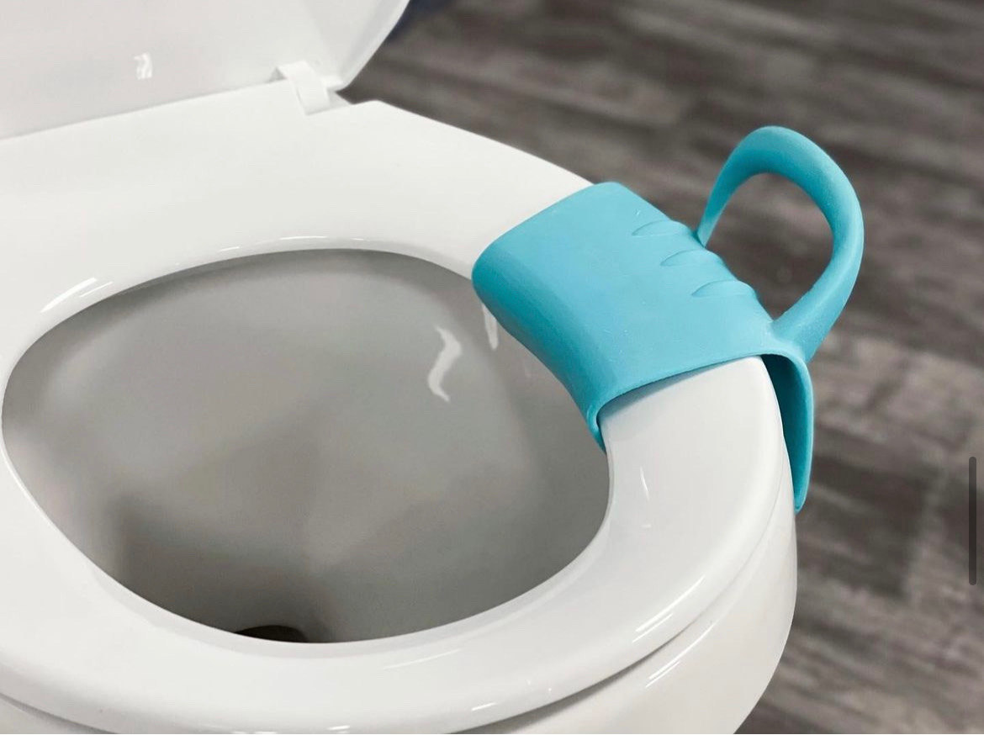 | 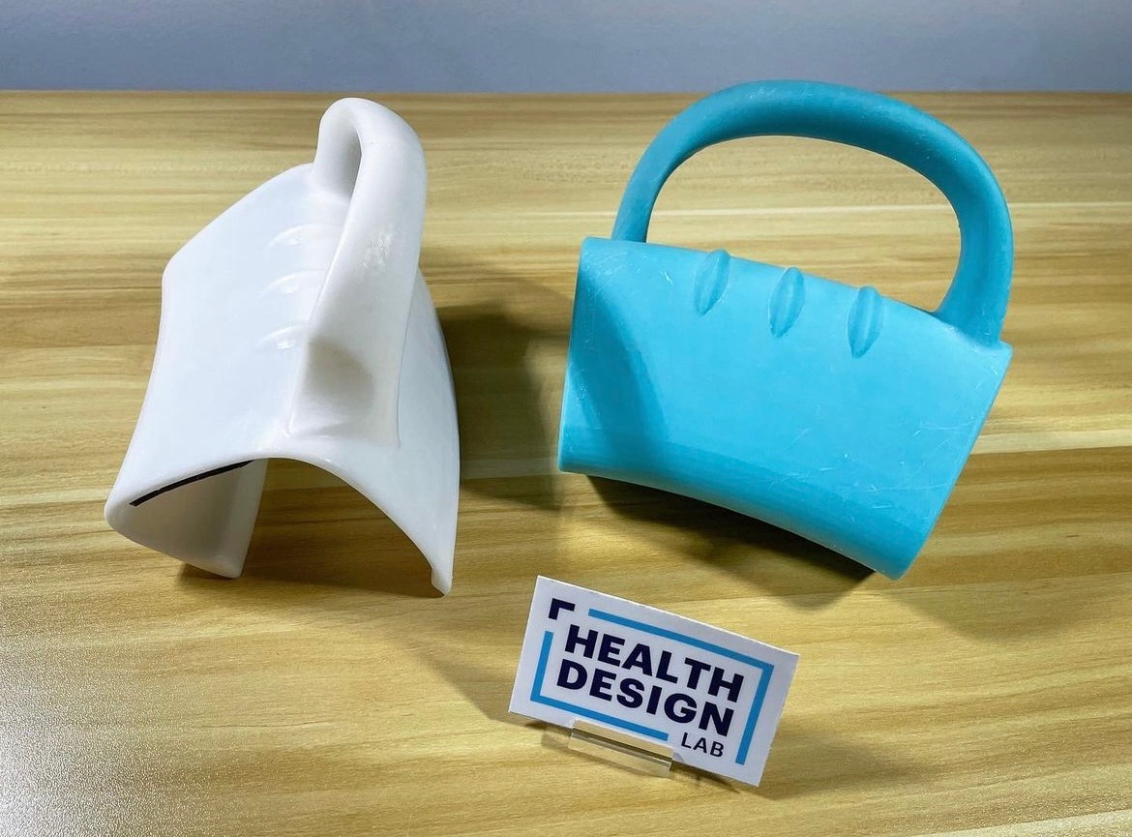

We conducted surveys with potential users of the device to validate our concept and better understand what they thought of the device and how they would interact with it. When the surveyed group was shown the current Grip ‘N Go design, 94.4 per cent of respondents indicated that they were interested in using the product.

LESSONS LEARNED

The Grip ’N Go transfer tool has the potential to dramatically increase individuals’ confidence in their ability to perform toilet transfers. This translates to a significant increase in these individuals’ independence, ability to participate in public activities, and pursue more opportunities because they will be less limited by accessible restroom availability. Positive user feedback shows that our design is a functional solution to challenging wheelchair transfers given that most of those surveyed also indicated interest in using the device.

There are several unexplored avenues and unanswered questions with regard to product development and refinement. The principal feature that we are interested in integrating in the future is creating the device from an antimicrobial plastic polymer to enhance the sanitation of the device, which users indicated was highly important to them. Additionally, further design for manufacturing is needed to assess feasibility for commercial production, as this was not a focus during our design process. While Grip ’N Go currently has a weight limit of 90 kgs (200 lbs), in the future we would like to increase Grip ’N Go’s weight bearing capacity to make it available to people with a higher BMI (weight).

Over the course of the design process, we learned about and developed an appreciation for the importance of human-centred design. Speaking to our potential users and learning their actual pain points and needs showed us that a complex issue could be addressed with a relatively simple solution that was dramatically different from our initial expectations. Another important aspect of the design process that we had underestimated was the nuances of design iteration. Our current design underwent countless rounds of redesign, and we found that seemingly insignificant details had major implications for the device’s functionality and comfort. We learned that the process of design is not linear, and several times found ourselves returning to an earlier iteration so we could branch in a new direction. Ultimately, we learned to allow ourselves to be guided by our failures rather than our perception of where we should go next.

DESIGN INSIGHT COMMENTARY

The article highlights the importance of hygiene and safety in public restrooms for those using wheelchairs. I have a feeling the findings would go beyond wheelchairs and prove useful for others with mobility issues as well. Especially for getting off the toilet back to standing for those using canes and walkers. This article adds value to the literature on disabilities and aging.

One issue that can be addressed in future research and articles is how to keep the Grip ’N Go device sanitary once it is removed from the unsanitary toilet. I suppose it can be put into a bag, which can then be cleaned later. I would also like to learn about (in a future article) the ease of getting the Grip ’N Go onto the toilet and off again.

Finally, I do hope they are applying for a patent for this. It is a great solution for many, and I also hope the authors continue to make tweaks to the product so it can be improved for heavier adults. I hope the authors will write another article once they have gathered data from users and made any other revisions.

Deborah Heiser, PhD

Adjunct Professor, Psychology, SUNY Old Westbury, NY

Founder/CEO, The Mentor Project

TEDx Speaker

REFERENCES
- Koontz A, Bass S, Cooper R. Independent Wheelchair Transfers in the Built Environment: How Transfer Setup Impacts Performance. 2015 Nov 18 [cited 2023 Apr 24]; Available from: http://herl.pitt.edu/ab/
- Rice LA, Peterson EW, Backus D, et al. Validation of an individualized reduction of falls intervention program among wheelchair and scooter users with multiple sclerosis. Medicine (Baltimore). 2019 May;98(19):e15418. doi: 10.1097/MD.0000000000015418
- Sung J, Trace Y, Peterson EW, et al. Falls among full-time wheelchair users with spinal cord injury and multiple sclerosis: a comparison of characteristics of fallers and circumstances of falls. Disabil Rehabil. 2019 Feb;41(4):389–95. doi: 10.1080/09638288.2017.1393111
ACKNOWLEDGEMENTS
Our team would like to thank the personnel of the JeffSolves program; and the Health Design Lab, including Morgan Hutchinson MD, Robert Pugliese PharmD, Bon Ku MD, and MaryEllen Daley. We would also like to thank Tod Corlett and Eric Schneider, our mentors from the industrial design program at Thomas Jefferson University. We would also like to thank Delve Engineering, Savvy Corporation, and the occupational therapists, physical therapists, and physicians at Thomas Jefferson University Hospital. Their mentorship, feedback, and resources were invaluable to the design of this project and device.

PEER REVIEW
Not commissioned. Externally peer reviewed.

CONFLICTS OF INTEREST
The authors declare the following conflicts of interest: The ownership of patented intellectual property mentioned in this article.

FUNDING
None

ETHICS COMMITTEE APPROVAL
None

